**Connecting to mysql to fetch the derived restaurant ids.**

Open the browser on hortonworks sandbox and visit the URL 10.80.2.4:4200. It will ask for the login as shown below:

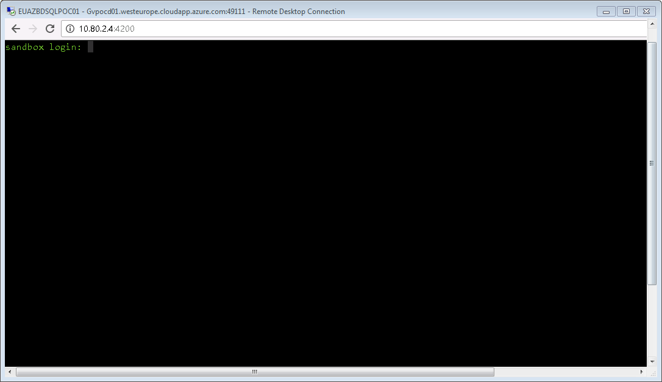

Provide the username and password

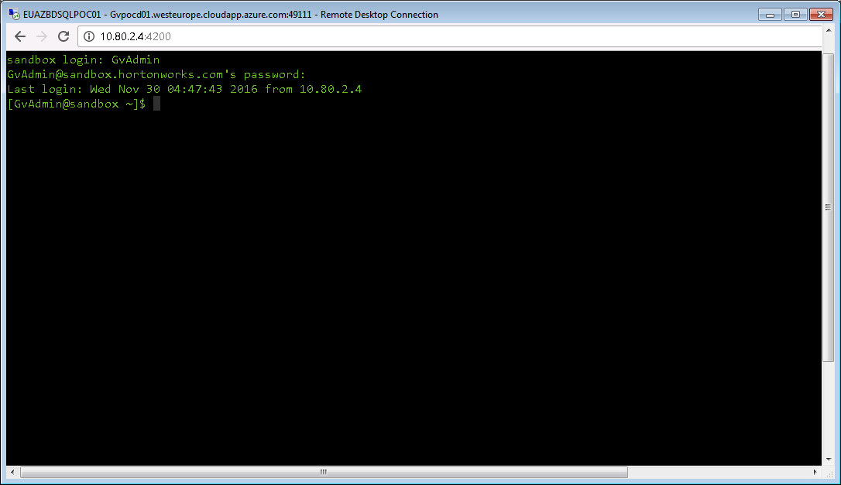

Type **sudo –s** and press Enter. It will ask prompt for the password. Provide the password

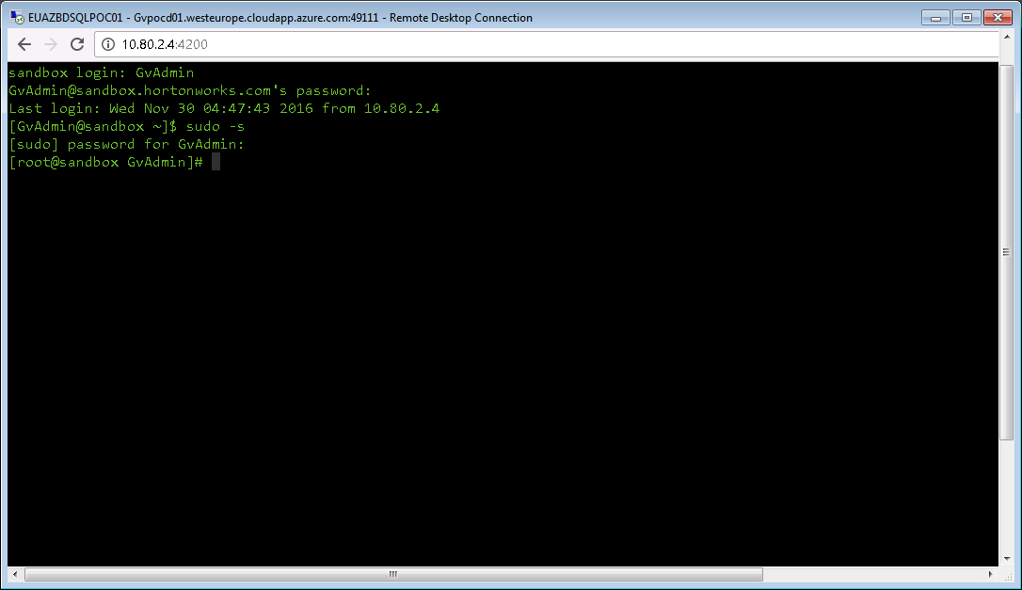

Type **mysql –uroot –p** and press enter. When prompted for password, please press enter.

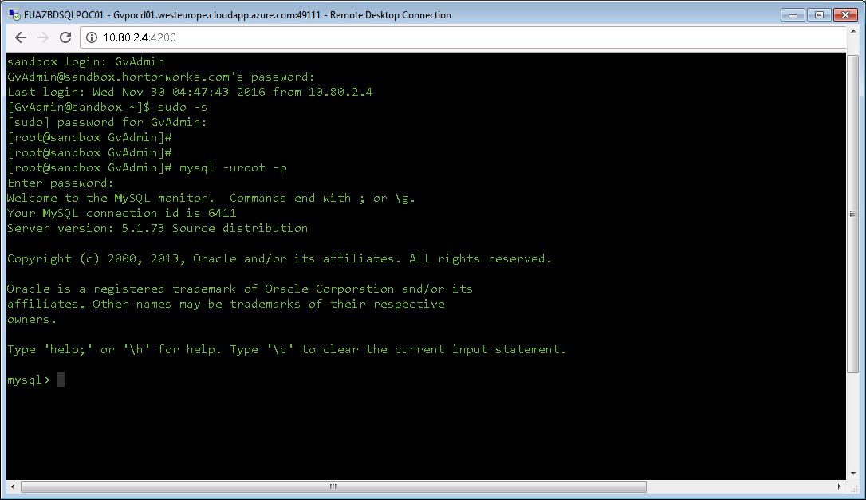

Type **use grosvenor** and press enter.

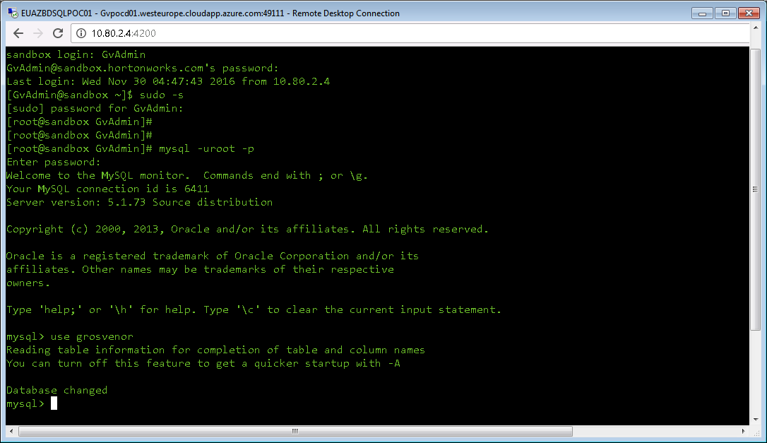

Type **SELECT * FROM twitterlist LIMIT 1;** and press enter.

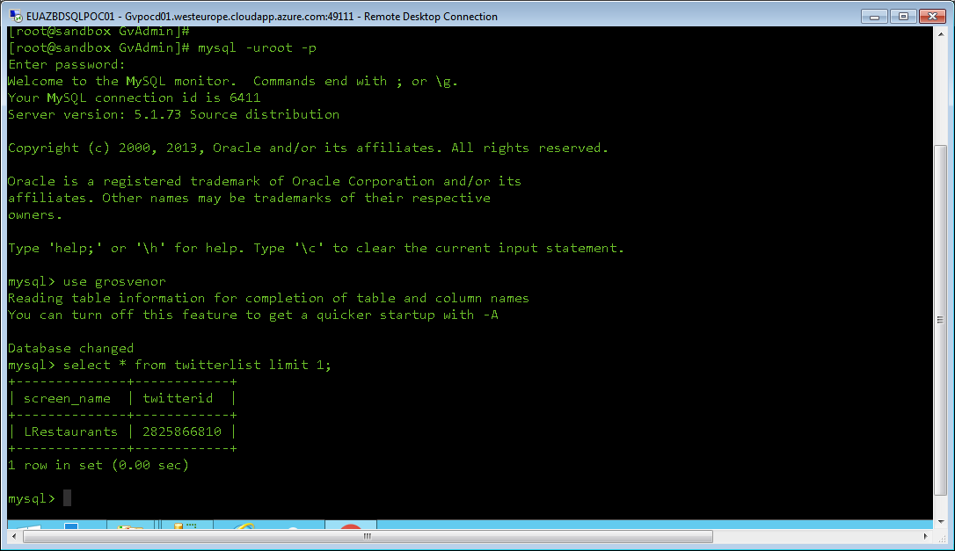

**NOTE:** Change the limit appropriately in the query to get more ids.